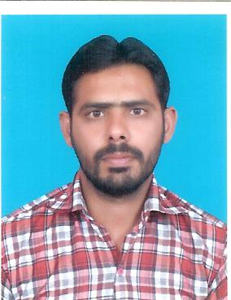Muhammad Rashid

Ali Hajwairy Colony Near Nawab Pur Road Alhateem Madarsa Street Babar Khan House

E. Mail Address:asim_mcs40@yahoo.com

Cell No: +92-3017788788

|  |  |  |  |  |  |  |
| --- | --- | --- | --- | --- | --- | --- |
| **Personal Detail:**  **Father Name: Muhammad Qasim**  **Date Of Birth: 01 August 1989**  **CNIC Number: 36301-90524703**  **Nationality: Pakistani**  **Marital Status: Single**  **Gender: Male** | | | | | | |
| **CAREER OBJECTIVES:** | | | | | | |
| Obtain a position as a computer operator through which I utilize my knowledge in a good manner.And serve in my field. | | | | | | |
| **QUALIFICATION:** | | | | | | |
| **Degree** | **Year** | **Marks Detail/GPA** | **Division** | **Subjects** | **Board/Inst** |
| Matriculation | 2005 | 388/850 | 2nd | Science | BISE Multan |
| Intermediate | 2008 | 618/1100 | 2nd | Eco, Computer | BISE Multan |
| Graduation | 2011 | 521/800 | 1st | Eco, Computer A,B | B.Z.U Multan |
| Masters | 2014 | 3.0 | 1st | Computer | B.Z.U Multan |

|  |  |  |  |  |  |
| --- | --- | --- | --- | --- | --- |
| |  | | --- | | **COMPUTER SKILLS:**   * Ms Office(Microsoft Word, Microsoft Excel) Internet. * C++ * PHP,HTML,CSS,ADOBE PHOTOSHOP | | **LANGUAGE SKILLS:**  English, Urdu. | | **HOBBIES:**  Cricket ,Study, Movies, Sight Seeing | | **Reference:**  Will Be Furnished Upon Demand. | |  |